MACHINE LEARNING

Machine learning is a growing technology which enables computers to learn automatically from past data. Machine learning uses various algorithms for building mathematical models and making predictions using historical data or information.

Currently, it is being used for various tasks such as

* Image recognition
* Speech recognition
* Email filtering
* Facebook auto-tagging recommender system

And many more.

What is Machine Learning

Machine learning is said as a subset of artificial intelligence that is mainly concerned with the development of algorithms that allow a computer to learn from the data and past experiences on their own.

The term machine learning was first introduced by ARTHUR SAMUEL in 1959. We can define it in a summarized way as:-

Machine learning enables a machine to automatically learn from data, improve performance from experiences, and predict things without being explicitly programmed



A machine has the ability to learn if it can improve its performance by gaining more data.

How does Machine Learning work

A machine learning system learns from historical data, builds the prediction models, and whenever it receives new data, predicts the output for it.

The accuracy of predicted output depends upon the amount of data helps to build a better model which predicts the output more accurately.

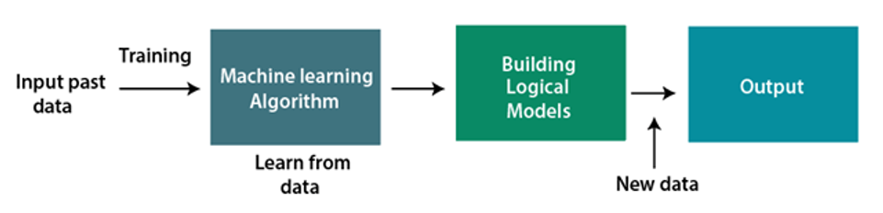

Features of Machine Learning

* Machine learning uses data to detect various patterns in a given dataset.
* It can learn from past data and improve automatically.
* It is a data-driven technology.
* Machine learning is much similar to data mining as it also deals with the huge amount of the data.

Need for Machine Learning

* Rapid increment in the production of data.
* Solving complex problems, which are difficult for a human.
* Decision making in various sector including finance.
* Finding hidden patterns and extracting useful information from data.